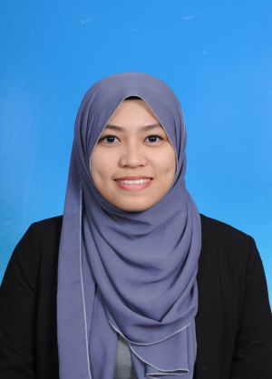**NAME ROS ASIAH BINTI ROSLEE**

**ADDRESS NO 10-0-4 KELUMPUK SUNDING MALAM,**

**AMPANG ULU KLANG , 52000 KUALA LUMPUR**

**D.O.B 23 JULY 1993**

**NIRC 93073-06-5942**

**HP No. 017-8801079**

**E-mail rosasiah.roslee@gmail.com**

**Objective**  Application for internship in a well-establish company in order to gain experience in the working environment as well as to gain self- development and motivation.

**Experience** Texas instruments Malaysia (TIM)

- Specialization : Manufacturer

Sk Jimah Baru, Seremban

- Specialization : Teacher

**Accomplishment** Excellent speaking and writing in Malay language.

**And skill** Good speaking and writing in English Languange.

Excellent in Microsoft Word, Powerpoint and Excel .

Have Business and Management knowledge.

Work well, punctual, helpful, willing to share knowledge and expertise with others ( concern about work quality ).

Fast leaner with a drive to succeed.

Enthusiastic to gain a new experience.

**Interest** Reading

Surfing Internet

Baking

**Education** Name Of University : Universiti Kuala Lumpur Business School

Bachelor of business administration (HONS) in Management and Entrepreneurship

CGPA : 2.94

: Sekolah Menengah Kebangsaan Temin, Jerantut STPM

CGPA: 2.34

: Sekolah Menengah Kebangsaan Damak, Jerantut

SPM (4A3B1C)

**Major Course** Marketing Management

Human Resource Entrepreneurship

Finance Operation

**References**  Sheikh Muhamad Hizam bin Sheikh Khairuddi

Academic Advisor

Universiti Kuala Lumpur Business School